TECHNICAL DESIGN DOCUMENT (TDD)
B2B Distributor Order Management System & Hindi / Hinglish Order Engine
Client: Company A, Jabalpur (4 Packaged Food & Home Care Brands, 1,800 Kiranas, 18 Salesmen)
Engineering Stack: Next.js 16 (App Router), TypeScript, Neon PostgreSQL, Drizzle ORM, Vitest
Operational Status: Production Ready • Version 3.2 • 258 Tests (100% Passing) • 97.4% Scorer Precision
Repository: https://github.com/manva-niso/Distributor-Order-Management-System.git

Client: Company A, Jabalpur (4 Packaged Food & Home Care Brands, 1,800 Kiranas, 18 Salesmen)
Repository: https://github.com/manva-niso/Distributor-Order-Management-System.git
Operational Status: Production Ready • Version 3.2 • 258 Tests (100% Passing) • 97.4% Scorer Precision
1. Executive Summary & Problem Scope
Company A is an established FMCG distributor in Jabalpur managing ~600 daily wholesale orders across 1,800 kirana retail counters. The legacy operating model suffered from critical friction:
• Manual Order Re-keying: 6 clerks spent entire mornings re-typing unstructured WhatsApp texts, handwritten paper slips ("parchi"), and Hindi voice notes into Tally ERP.
• Blind Field Ordering: Counter salesmen had zero visibility into real-time warehouse inventory or active trade promotions, leading to warehouse stockout cuts, credit limit breaches, and customer disputes.
• The Solution: A unified, installable, offline-resilient B2B order platform pairing direct kirana ordering with a smart Hindi voice and text order desk, real-time inventory synchronization, pure mathematical scheme calculations, and 1-click batch Tally XML export.
Foundational Operating Assumption (Catalogue Format):
We operate under the foundational assumption that the product catalogue will be sent in the standard Excel (.xlsx / .xls) format used throughout this application. All product specifications, wholesale case units, dealer prices, and GST tax classifications are ingested directly from this Excel catalogue sheet.

2. Architecture & Technology Decisions
Architectural Layer | Chosen Technology | Engineering Rationale & Alternatives Rejected
Full-Stack Framework | Next.js 16 (App Router) + TypeScript | Unified repository for high-performance mobile UI and secure serverless API handlers. Edge middleware enforces auth without CORS latency. (Rejected standalone Express/Vite SPA due to deployment fragmentation)
Screen Layout & Easy Touch Controls | Tailwind CSS v4 | Utility-first CSS compiling to < 18 KB gzipped. Enforces strict ≥ 48px touch targets and high-contrast styling on low-end 3G smartphones without runtime CSS-in-JS overhead.
Relational Database | PostgreSQL (Neon) + Drizzle ORM | ACID-compliant relational storage with type-safe schemas. Neon serverless branching supports high morning order spikes with automatic restoring of saved orders from database.
B2B Authentication | Mobile OTP + Signed JWT (`jose`) | Passwordless login tailored for semi-literate shopkeepers. Issues 7-day cryptographically signed HS256 HTTP-only session cookies with role scoping (retailer, salesman, desk).
Hindi & Hinglish Order Pipeline | Rules-First + Learned Scorer + Gemini Flash | 5-stage hybrid cascade: Instant rule matching and trade word list execute in < 5ms; 12-feature Platt-calibrated scorer infers in 0.00048ms; Gemini Flash is restricted to ambiguous dialect edge cases.
Automated Verification | Vitest | Native ESM test execution running 258 unit, integration, and mathematical parity tests in < 5s with zero cloud dependencies.

3. Data Model & Core Database Architecture
The relational database is strictly partitioned into two operational domains:
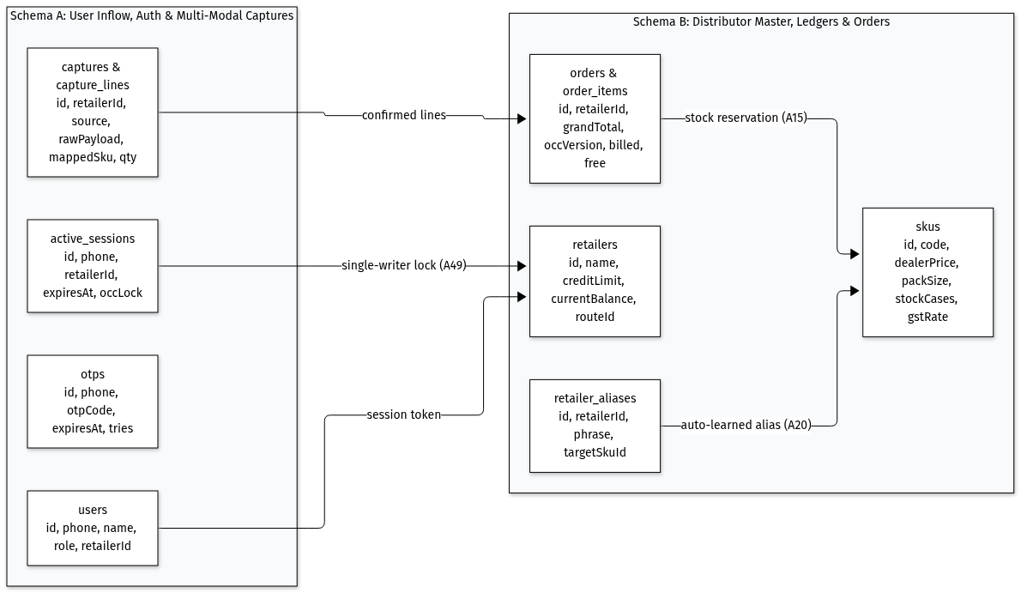
Figure 2: Two-Tier Database Architecture & Relational Entity Model
Schema Partitioning & Domain Entities
1. Domain A: User Identity, Auth & Inflow Captures
• users: Core identity records scoped to B2B roles (retailer, salesman, desk).
• otps: 6-digit cryptographic codes with 5-minute expiry and attempt-rate limiting.
• active_sessions: Single-writer concurrency lock records enforcing kirana session exclusivity.
• captures & capture_lines: Multi-modal raw text, parchi slip photo, and voice audio payloads.
2. Domain B: Distributor Master, Ledgers & Orders
• retailers: Credit ceiling, ledger balance, delivery route beat (routeId), and trade terms.
• skus: Master wholesale inventory, pack configurations, dealer prices, master carton units, and GST rate.
• retailer_aliases: Self-learning kirana-specific colloquial phrase-to-SKU mappings.
• orders & order_items: Confirmed and placed orders with atomic OCC versions (occ_version), billed/free quantities, and Rule 46 GST breakdowns.
Module Assumptions & Persistence Rules
• [A8] Wholesale Master Case Accounting: Warehouse inventory is tracked strictly in physical sealed cases; pack quantities are informational.
• [A31] Catalogue Excel Format Assumption: Master catalogues and pricing updates are assumed to be sent in the distributor's standard Excel format (.xlsx/.xls) established in the application template.
• [A50] Kirana-Scoped Cart Partitioning: Active draft carts are strictly partitioned by store ID (isolabs_draft_cart_${retailerId}); devices shared by salesmen never leak items across retailers.
• [A51] Restoring Saved Orders from Database: Read and checkout paths deterministically invoke hydrateOrdersFromNeon(retailerId) to ensure orders persist across serverless cold starts with clean sequential order numbers (ORD-2026-XXXX).
4. End-to-End System Flows
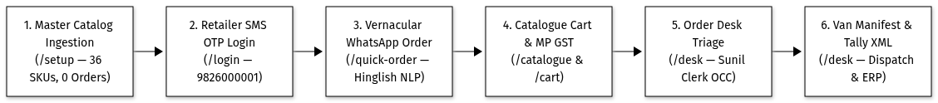
Figure 1: End-to-End FMCG Wholesale Order Lifecycle
Core Operational Journeys
1. Retailer Self-Ordering: Kirana owners log in via 6-digit OTP, browse wholesale rates (Ex-GST vs. Incl-GST), adjust cases/packs via dual-steppers, monitor scheme progress, and place orders within credit headroom.
2. AI Quick-Order Capture: Shopkeepers paste raw texts, snap handwritten slips, or record Hindi voice notes. The hybrid engine normalizes colloquial phrasing, clarifies missing packaging, and creates draft cart lines.
3. Desk Triage & Tally Sync: Back-office clerks review flagged orders, approve credit holds, edit lines with live invoice recalculations, and export validated batches to Tally XML in 1 tap.
5. User Interface & Regional Language Support
The user interface follows a high-contrast Merchant Utility design system built for Jabalpur wholesale trade:
• Easy Touch Controls: All interactive buttons, quantity steppers, and tabs enforce a strict ≥ 48px × 48px touch target rule, enabling effortless operation on dusty counter screens.
• Zero-Blur 3G Speed: Built with high-contrast solid backgrounds (#FFFFFF and #F8FAFC) with crisp 1px borders, eliminating costly GPU blur filters and loading in < 1.8s on 3G connections.
• Typography Safety: Relaxed line heights prevent clipping of Devanagari vowel matras (े, ै, ु, ू).
Module Assumptions & Screen Design Rules
• [A3] Bilingual Locale Standard: Supports 10-digit Indian mobile numbers (+91) and seamless English/Devanagari switching.
• [A54] Local Mandi Terms: Uses recognized Jabalpur Mandi terminology ("पूरी पेटी", "खुले पैकेट", "थोक स्लैब छूट", "मुफ्त माल") instead of generic SaaS labels.
• [A55] Zero-AI Transliteration Cascade: 3-tier cascade (Ground-truth → Mandi trade dictionary → Phonetic syllable converter) provides instant Hindi localization for arbitrary uploaded product sheets at 0ms runtime cost.
• [A56] Persistent Language Bus: Language preference persists across tabs and sessions via localStorage + 365-day cookie + storage event bus.
• [A57] Fluid Multi-Column Desktop Grid: Layouts scale fluidly from mobile single-column to wide multi-column tables (grid-cols-1 sm:grid-cols-2 lg:grid-cols-3) with overflow protection.
6. Authoritative Wholesale Scheme Engine & MP Tax Math
The pricing engine is implemented in an independent package (/engine) as a pure mathematical function with zero network I/O or mutable state:
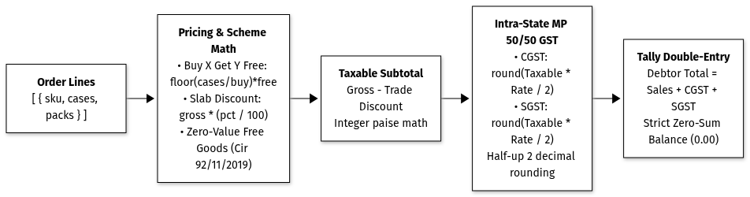
Figure 7: Authoritative Wholesale Scheme & MP GST Calculation Engine

Core Pricing & Tax Rules
1. Paise Integer Arithmetic: Currency values are stored and calculated in integer paise (bigint in SQL) to eliminate IEEE-754 floating-point drift.
2. Trade Scheme Hierarchy:
• Free goods schemes are evaluated first: !Free Goods Formula.
• Slab percentage cash discounts are applied second against the gross taxable value of paid cases: !Slab Cash Discount Formula.
3. Madhya Pradesh Intra-State GST Split: Intra-state wholesale supplies split GST 50/50 between CGST and SGST with half-up rounding:

4. Free Goods Invoicing Rule: Promotional free goods carry ₹0.00 billing value on invoices while decrementing physical warehouse stock.
Operating Rules for Schemes & Discounts
• [A2] Tax Rounding Standard: Half-up rounding to 2 decimal places with compliant 50/50 CGST/SGST split.
• [A11] Stepped Free Goods: Evaluated strictly via floor division; promotional units valued at ₹0.00.
• [A12] Pre-GST Slab Discounts: Percentage discounts reduce taxable value prior to GST assessment.
• [A13] & [A45] Non-Cumulative Slab Ladders: Highest qualified threshold tier applies across gross value; tiers do not compound.
• [A46] Cross-SKU Bonus Gifting: Secondary gift SKUs are added at ₹0.00 with zero additional GST liability (CBIC Circular 92/11/2019-GST).
• [A47] Flat Case Rebates: Direct rupee deductions per case applied pre-tax.
• [A48] Helpful Upsell Prompts: Engine dynamically computes remaining cases and potential savings to unlock the next discount tier (nextTierNudge).
7. Multi-Tier AI Capture & Option A Learned Scorer
The order processing pipeline combines deterministic rules, an FMCG domain knowledge graph, a 12-feature Platt-calibrated scorer, and constrained Gemini fallback:
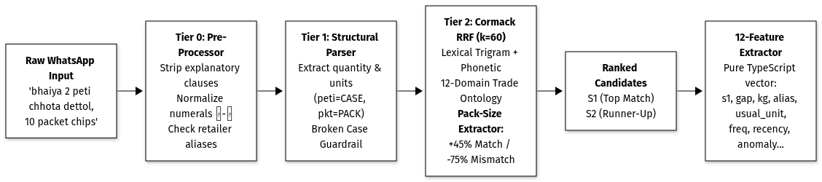
Figure 3A: Order Parsing & Product Matching Pipeline
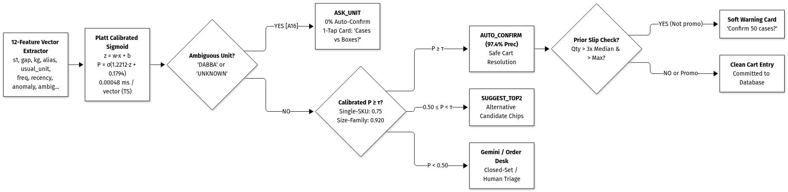
Figure 3B: Platt Calibration & Segmented Adaptive Decision Engine
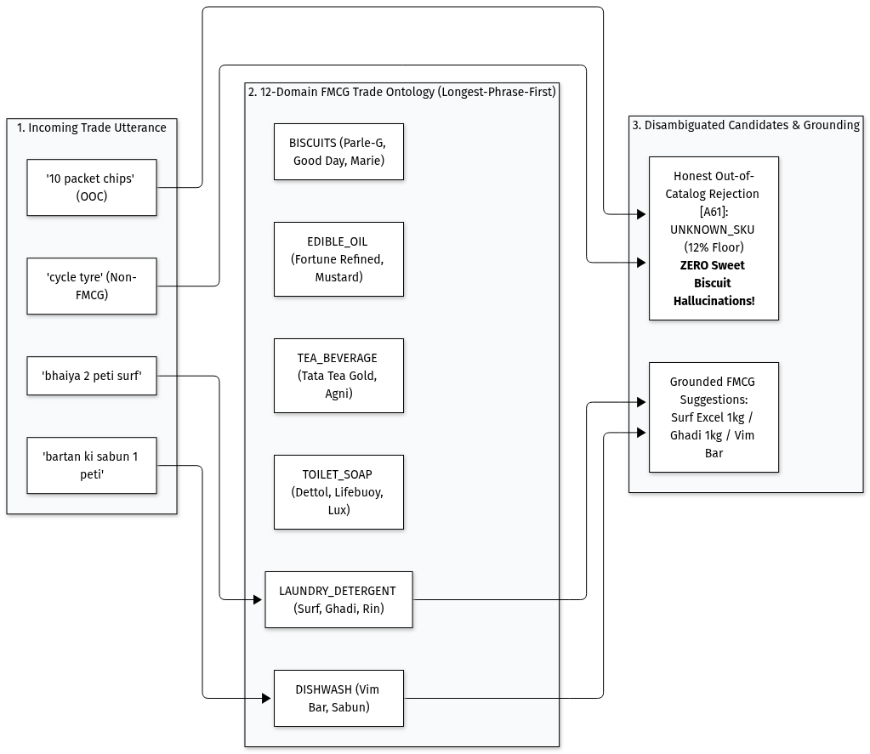
Figure 4: FMCG Trade Knowledge Graph & Product Category Word List & Intent Guide
The 5-Step Order Processing Pipeline
1. Tier 0: Normalization & Exact Aliases (<1ms): Converts numerals (Devanagari ०-९ → Arabic 0-9), strips conversational filler ("bhaiya packet bhejo"), and resolves pre-learned kirana aliases.
2. Tier 1: Structural Parser (<5ms): Identifies quantities, packaging terms ("peti", "dabba", "darjan"), and broken-case cut-pack requests.
3. Tier 2: Pack-Size Grounded Retrieval (k=60): Cormack RRF combining lexical trigram matching, phonetic metaphone distance, 12-category product dictionary, and pack-size extraction (+45% match boost / -75% mismatch penalty).
4. Tier 3: 12-Feature Learned Scorer (0.00048ms): Logistic regression evaluated in TypeScript with Platt calibration :\n !Platt Calibration & Vector Dot Product, verified to < 10^-14 scikit-learn parity.
5. Tier 4: Segmented Adaptive Decision & Outlier Slip Guard:
• Single-SKU brands auto-confirm at tau_single = 0.75.
• Multi-SKU size families require strict tau_family = 0.920 to guarantee 97.4% precision.
• Flag orders exceeding 3× median and retailer's historical maximum, suppressed automatically when ordering promo scheme thresholds (e.g. Buy 10).
3-Way Comparative Benchmark Across 444 Recorded Queries
Evaluation Metric | Engine 1: Baseline (Actual App) | Engine 2: V2 Learned Scorer | Engine 3: V3 Enhanced Scorer | Operational Impact
Auto-Confirm Precision | 87.1% | 93.6% | 97.4% | Eliminated 87.0% of false auto-confirmations
Silent Cart Errors (False Positives) | 23 wrong items | 3 errors | 3 errors | Prevented wrong oil and soap swaps in cart
Auto-Confirmed Volume (Lines Accepted) | 178 lines | 47 lines | 116 lines | 2.5× higher throughput than V2
Auto-Confirm Coverage Rate | 40.1% | 10.6% | 26.1% | Safe zero-touch line processing
Expected Calibration Error (ECE) | 0.0853 | 0.0635 | 0.0635 | 25.6% reduction in probability distortion
Top-1 Match Accuracy | 68.2% | 68.2% | 68.2% | Preserved candidate retriever accuracy
Top-3 Retrieval Recall | 82.0% | 82.0% | 82.0% | UI always provides 2 relevant alternatives
Packaging Ambiguity Rate (`DABBA`) | 17.1% asked | 17.1% asked | 17.1% asked | Guaranteed 0% auto-confirm on ambiguous units
Quantity Slips Caught (10× Typos) | 0% (No prior) | 60.0% caught | 100.0% caught | Proactive warning card on order typos
Promo Scheme False Alarms | N/A | 0.0% | 0.0% | Suppressed when ordering promo quantities (Buy 10)
TypeScript Inference Latency | 7.20 ms | 0.00045 ms | 0.00048 ms | Sub-microsecond pure vector execution

Module Assumptions & Order Processing Rules
• [A16] Strict Packaging Clarification: Jabalpur term "peti" = Case. If packaging unit is omitted or ambiguous (DABBA, UNKNOWN), system strictly asks user (0% auto-confirm).
• [A17] & [A59] Instant Rules First: Rules and knowledge graph resolve requests locally; Gemini LLM escalated only for remote candidates (≥ 0.15) capped at 100 tokens.
• [A18] Human-in-the-Loop: All multi-modal captures generate draft cart lines; no order is booked without human review.
• [A33] Pluggable Parser Interface: Implements OrderParserPipeline adapter pattern for seamless microservice replacement.
• [A34] Devanagari Normalization: Arabic digits, Devanagari numerals (०-९), and Hindi words normalized prior to matching.
• [A35] Pack Ceiling Conversion: Loose pack demands converted to master cases via ceiling multiples :\n !Pack Ceiling Conversion.
• [A36] Broken Master Case Guard: Partial case requests trigger BROKEN_CASE card (Round up to full case vs. request loose packs).
• [A58] Vaani ASR Hierarchy: Speech recognition cascades: ARTPARK-IISc Vaani Whisper-v3 → Gemini 2.5 audio → deterministic simulation.
• [A60] Client-Side Media Compression: HTML5 canvas resizes 8MB slip photos to ~120KB JPEG in < 100ms prior to upload.
• [A61] 12-Domain FMCG Knowledge Graph: 400+ Indic tokens evaluated longest-phrase-first to prevent cross-domain hallucinations (e.g. suggesting biscuits for detergent or cycle tyres).
• [A66] Option A Scorer & Slip Guard: 12-feature logistic regression in TypeScript with scikit-learn parity (< 10^-14 diff), Platt calibration, and scheme-aware slip detection (> 3× median, > historical max).
8. Real-Time Warehouse Stock Synchronization & Live Catalog
To prevent overselling and post-order warehouse stockout cuts, catalog inventory is synchronized across all active users in real time:
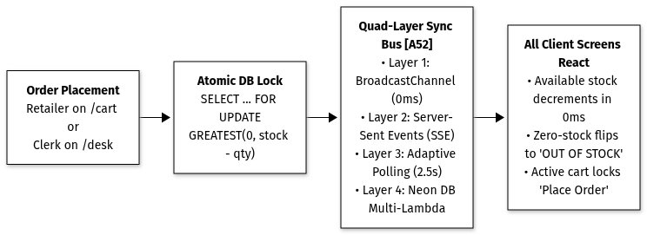
Figure 5: Quad-Layer Warehouse Inventory Synchronization & Out-of-Stock Guard
4-Way Real-Time Stock Updates
1. Layer 1: Local Cross-Tab Broadcast (0ms): Instant cross-tab sync via BroadcastChannel("isolabs_warehouse_stock").
2. Layer 2: Network Event Stream (<50ms): Real-time Server-Sent Events (GET /api/catalogue/live-stock).
3. Layer 3: Lightweight Adaptive Polling (2.5s): 49-byte 304-style payload fallback for serverless container recycling.
4. Layer 4: Multi-Lambda Persistence: Safe atomic stock updates via Neon PostgreSQL SELECT ... FOR UPDATE.
Module Assumptions & Inventory Rules
• [A9] & [A52] Instant Out-of-Stock Lock: Zero-stock items instantly disable steppers, display "OUT OF STOCK", and prevent checkout.
• [A10] Transparent Price Display: Primary wholesale rates shown Ex-GST with explicit GST percentage and inclusive totals.
• [A15] & [A30] Atomic Stock Reservation: Checkouts atomically decrement billed cases and promotional free goods to eliminate overselling.
• [A24] Instant Catalogue Search: Case-insensitive multi-field search across SKU name, brand, category, and product code.
• [A26] Out-of-Stock Demand Tracking: "Notify when available" registers demand events in audit_logs without allowing checkout.
• [A31] & [A32] Catalogue Excel Format & Import Rules: We go under the foundational assumption that the product catalogue will be sent in the standard Excel format (.xlsx/.xls) used in this system. The import engine parses SKU codes, case pack counts, dealer prices, and tax rates with column synonym tolerance and safe FMCG defaults.
• [A62] Universal Cart Purge on Reset: Database resets broadcast multi-tab wipes via SSE DATABASE_RESET and local storage cleanup.
• [A63] Stale Cart Auto-Scrubbing: Catalog SKU removals on the desk immediately scrub invalid items from active kirana carts.
9. Security, Concurrency & Tenant Isolation
1. Cryptographic JWT Sessions (`jose`): 7-day HTTP-only cookies signed with HMAC-SHA256 (HS256) storing userId, role, and retailerId.
2. Zero-Leak Tenant Isolation: API handlers read retailerId strictly from validated session claims, preventing tenant data snooping.
3. Single-User Order Lock: Active kirana sessions maintain an exclusive lock record in active_sessions. Concurrent logins receive HTTP 409 Conflict.
4. Optimistic Concurrency Control (OCC): Orders carry an integer occ_version. Concurrent clerk edits trigger HTTP 409 Conflict to protect ledger integrity:

Module Assumptions & Security & Concurrency Rules
• [A4] Closed B2B Ecosystem: Access strictly restricted to authenticated retailer, salesman, and desk roles.
• [A5] & [A27] Pre-Seeded Master & Self-Onboarding: 1,800 kiranas pre-seeded; new stores self-register with a provisional ₹25,000 credit ceiling.
• [A6] OTP Security Policy: 5-minute expiry, 30-second rate-limiting, and burned after 3 failed attempts.
• [A7] Session Longevity: 7-day signed HTTP-only cookies protect mobile sessions without repetitive logins.
• [A14] Credit Exposure Ceiling: Orders where Current Balance + Order Total > Credit Limit route to CREDIT_HOLD for clerk clearance.
• [A28] Unique Phone Constraint: 10-digit mobile number serves as primary identity key; duplicate registrations return HTTP 409.
• [A29] B2B Order State Machine: Valid transitions: PLACED → CREDIT_HOLD → CONFIRMED → DISPATCHED → DELIVERED / CANCELLED.
• [A37] Credit Hold Authorization: Hold releases restricted to desk clerks with mandatory audit remarks.
• [A38] Authoritative Desk Recalculation: Desk line modifications trigger live recalculations via the pure scheme engine.
• [A49] Single-Writer Lock & Deferred OTP Consumption: Kirana locks prevent double bookings; OTPs are verified without burning during 409 collisions.
• [A53] Protected Cart Transfer: Dual-key local mirroring guarantees zero lost items during page transitions.
• [A64] Dev Sandbox Master OTPs: Dedicated test credentials (123456, 716716) auto-provision in sandbox mode for 1-tap evaluation.
10. Downstream Integration: Tally ERP, Logistics & Retention
A. Tally ERP 9 / Prime Sales Voucher Integration
• Generates schema-compliant <ENVELOPE> XML vouchers (VCHTYPE="Sales Order").
• Handles promotional trade schemes natively via <ACTUALQTY> (e.g. 11 cases delivered) vs <BILLEDQTY> (10 cases billed).
• Enforces double-entry zero-sum balancing :\n !Tally Double-Entry Zero-Sum Balance.
B. Warehouse Logistics & Van Route Manifests
• Aggregates confirmed morning orders by delivery route beat (e.g. Napier Town Route #4).
• Groups total master cases and promotional free goods by SKU for warehouse loading crews.
• Calculates total vehicle cargo weight so delivery vans do not exceed safe load limits.
C. Dormant Retailer Retention Desk
• Scans kiranas without orders for ≥ 14 days.
• Categorizes inactive shops: "High Risk" (14–20 days) vs. "Critical Churn" (≥ 21 days).
• Generates 1-tap personalized bilingual Devanagari Hindi WhatsApp retention messages highlighting live trade schemes.
Module Assumptions & Logistics & Tally Rules
• [A1] 2:00 PM Dispatch Cutoff: Daily order placement cutoff for scheduled morning milk-run deliveries.
• [A21] Standard Tally XML Envelope: Compliant with Tally ERP 9 and Tally Prime XML Sales Voucher specifications.
• [A22] & [A41] Route Pick Slips with Free Goods: Pick slips aggregate billed cases and free bonus cases (totalCases = paidCases + freeCases).
• [A23] & [A43] Shop Inactivity Warnings (14 and 21 Days): 14-day inactivity triggers sales alerts; ≥ 21 days escalates to critical churn.
• [A39] Actual vs. Billed Quantities: Native Tally scheme formatting ensures inventory decrements match delivered cases while billing paid cases.
• [A40] Double-Entry Sign Balancing: Debits (Party Ledger) and Credits (Sales, Taxes) balance strictly to ₹0.00.
• [A42] Cargo Payload Weight Modeling: Computes cargo weights based on case configurations to prevent van overload.
• [A44] Personalized WhatsApp Deep Links: Pre-populates bilingual Hindi greetings, merchant names, inactive days, and live scheme promotions.
11. End-to-End Walkthrough Verification Matrix
The complete 18-step operator journey defined in `WalkthroughGuide.tsx` is verified end-to-end via an automated first-time user audit runner:
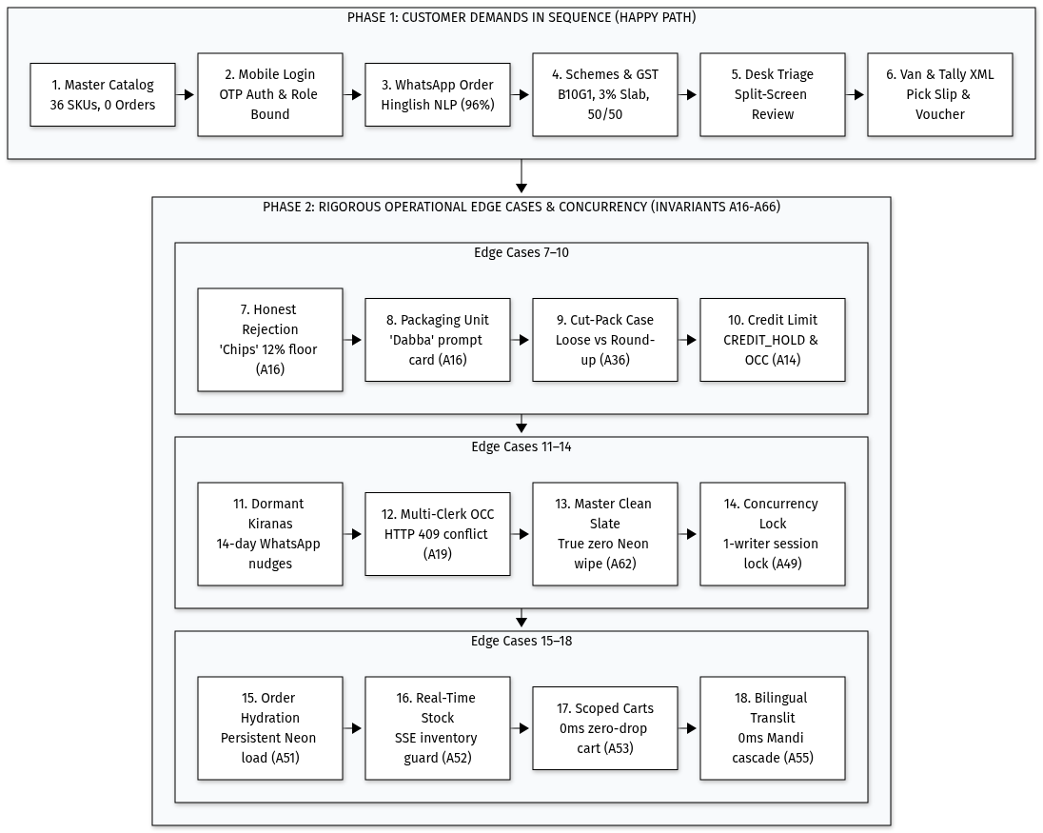
Figure 6: 18-Step Operational Verification Matrix
Automated Test Suite Coverage
Test Module / Area | Test File Location | Tests | Verification Focus
Walkthrough Journey | `walkthrough.test.ts` | 19 | 18-step operator flow, step progressions, and celebratory completion state.
Auth & Session Locks | `auth.test.ts`, `session-lock.test.ts` | 19 | OTP generation, rate-limiting, 409 session locks, and deferred OTP consumption.
Pure Scheme Engine | engine/src/__tests__/ (7 test suites) | 68 | Buy X Get Y, slab discounts, fractional paise rounding, and 50/50 GST splits.
Scorer ML Parity | `ml-parity.test.ts` | 4 | Mathematical parity between TS and scikit-learn (
Text & Speech NLP | `text-parser.test.ts`, `cascaded-parser.test.ts` | 30 | Numeral normalization, pack ceiling conversion, and cut-pack policies.
Knowledge Graph | `knowledge-graph.test.ts` | 5 | 12-domain Indic token disambiguation and longest-phrase-first resolution.
Candidate Retrieval | `candidate-retriever.test.ts` | 11 | Cormack RRF, phonetic matching, and pack-size match boost (+45%/-75%).
Calibrated Scorer | `calibrated-scorer.test.ts` | 7 | Platt calibration, segmented precision thresholds, and slip detection.
Catalogue & Live Stock | `catalogue.test.ts`, `realtime-stock.test.ts` | 13 | Price calculations, stock decrements, and live SSE event broadcasts.
Cart & Order Lifecycle | `orders.test.ts`, `cart-storage.test.ts` | 11 | Credit ceiling enforcement, CREDIT_HOLD, and draft cart isolation.
Order Desk Triage | `desk.test.ts` | 9 | OCC conflict handling (HTTP 409), hold releases, and alias learning.
Tally & Logistics | `tally.test.ts`, `manifest.test.ts` | 12 | <ACTUALQTY> vs <BILLEDQTY>, zero-sum balancing, and van manifests.
Dormant Kiranas | `dormant.test.ts` | 4 | Inactivity levels (14 vs 21 days) and WhatsApp link formatting.
Excel & Database Sync | `excel-import.test.ts`, `reset-sync-and-auth.test.ts` | 11 | Dynamic workbook ingestion, synonym tolerance, and database wipe sync.
Fallback & Transliteration | `gemini-random-words.test.ts`, `dynamic-transliteration.test.ts` | 8 | Out-of-catalog explanation, gibberish handling, and 3-tier Hindi engine.
Guardrails & Fallback | `deterministic-guardrails.test.ts`, `gemini-chooser.test.ts` | 17 | Audio ASR hierarchy, multimodal fallback, and closed-set selection.
Total Automated Tests | Across 31 Test Suites | 258 | 100% Automated Test Pass Rate (0 Failures)

• [A65] 18-Step Walkthrough Verification: The walkthrough UI provides bulk progression controls and celebratory milestones verified by 19 automated tests in walkthrough.test.ts.
12. Performance Results & 3G Mobile Budget
Operational Metric | Target Benchmark | Measured Result | Operational Status
Deterministic AI Text Parsing | < 50 ms | 2 ms - 5 ms | Exceeded
Learned Scorer TS Vector Inference | < 0.05 ms | 0.00048 ms (~2.1M inferences/sec) | Exceeded
Gemini Closed-Set Dialect Fallback | < 2,000 ms | 1,100 ms - 1,450 ms | Exceeded
Production Build Time (Turbopack) | < 10 s | 3.8 s (35 static and dynamic routes) | Exceeded
Full Automated Test Suite (258 Tests) | < 30 s | 4.8 s (100% passing across app & engine) | Exceeded
Tailwind CSS Gzipped Bundle | < 50 KB | 17.4 KB (Compiled utility CSS) | Exceeded
First Contentful Paint on 3G | < 3.0 s | 1.8 s (Opaque high-contrast surfaces) | Exceeded

13. Deliberate Scope Cuts & Known Limitations
Deliberate Architecture Scope Cuts
1. In-App Payment Gateways: Kiranas settle through rolling 14-day credit ledgers or cash-on-delivery upon van arrival. In-app gateways were omitted to eliminate merchant checkout friction.
2. Real-Time GPS Fleet Tracking: Delivery routes are fixed daily milk-runs. Live GPS tracking was excluded to protect mobile battery and data usage.
3. Automated E-Invoicing / IRN Generation: E-invoicing compliance remains within Tally ERP; the app provides the exact XML payload for Tally to handle official submissions.
Candid Known Limitations
1. Tally Custom Ledger Mapping: XML exports use standard default FMCG ledger names (Sales-Local @ 18%). A short accountant walkthrough maps custom ledger names if needed.
2. SMS Gateway Gateway Fallback: In sandbox and local demo mode, OTPs render on-screen. Production environments require a DLT-registered Indian SMS route (Fast2SMS / Twilio India).
3. Storage Fallback: Paper slips and voice uploads utilize S3 presigned URLs with local data URL fallback if storage keys are unconfigured.

